**OBJECT ORIENTED PROGRAMMING**

**LAB ASSIGNMENT -1**

**Generic Overview**

1. Overview of GCC and/or Dev C++ IDE (both can be discussed)
2. Installation process of CPP compiler (if needed)
3. Basic structure of CPP program
4. Using Operators (relational, bitwise, *etc.*)
5. Precedence and associativity rules.

**Programming Question**

1. Write a program (WAP) to display "Hello World" on console display.

Code:

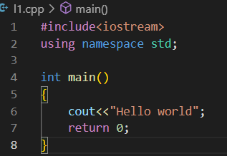

Output:



1. Write a C++ program to print prime no of 1 to 300 numbers.

Code:

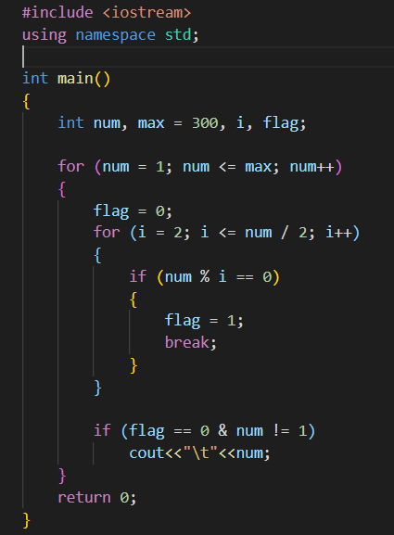

Output:



1. Write a C++ program that will ask for a temperature in Celsius and display it in degree Fahrenheit.[F=9C/5+32]

Code:

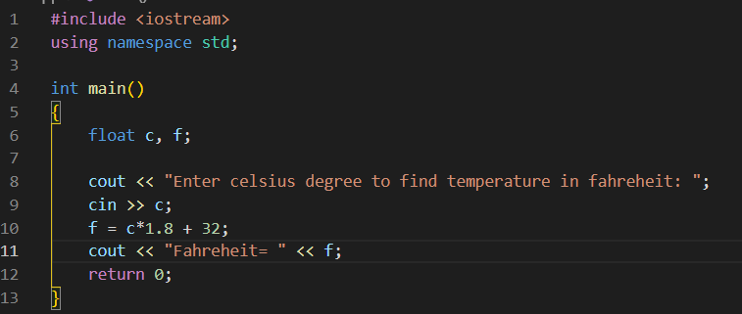

Output:



1. WAP to demonstrate simple if, if-else, else-if ladder, switch-case construct (with all possible variations).

Code:

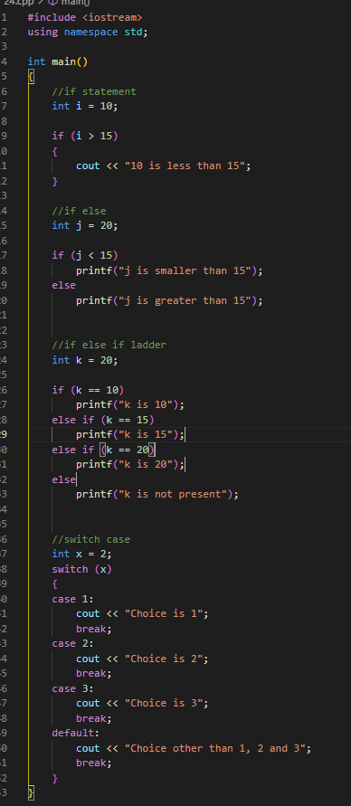

Output:



1. WAP to demonstrate for, while, do-while (with all possible variations), like for loop can be demonstrated without giving initialization in for construct or without giving increment in for construct.

**Sample:**

for (i=0; i<10; i++)

i=0

for (; i<10; i++)

i=0

for (; i<10;)

i++

code:

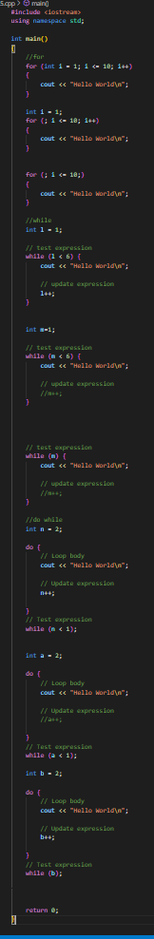

Output:

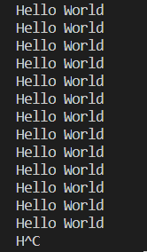

INFINITE LOOPS